THE ELECTRIC UNIVERSE
Marek S. Żbik

Abstract
The article discusses the role of electromagnetic forces in shaping the great structure of the Universe. Observation of clusters of galaxies across the observable Universe reveal a strange image of a highly porous structure containing large-sized voids entwined with fibrous threads made of galactic beads intertwined into a “Cosmic Web” with invisible forces. It is proposed that this type of structure, often found in colloidal solutions, may result from electromagnetic interactions rather than from many orders of magnitude of weaker gravitational interactions. The importance of electromagnetic interactions known from study of dust clouds associated with violent volcanic eruptions, forest fires and thunderstorms. Similar patterns are further seen within filament-like large structure of intergalactic environment, appearance of the galactic magnetic field as well as in the most primitive mineral components formation of the early solar proto-planetary nebula.

Keywords — Electric Universe, Universe structure
- INTRODUCTION
Most of the inhabitants of our planet never ask themselves what is the nature of the universe in which we live and what rules it governs so that it would be able to provide us with decent living conditions in our everyday life. During the day, the celestial vault separating us from the bottomless abyss of space with the veil of the blue dome gives a sense of security, and at night it illuminates with myriads of stars.
From the reports of astronomers' discoveries, we learned from the turn of the 19th and 20th centuries that these stars that we observe at night are celestial bodies similar to our Sun. Some of these stellar bodies are larger and smaller plasma globes made up mostly of hydrogen and helium. These stars, which we see with the naked eye, are only a handful of the enormous mass that astronomers can observe through telescopes, and which, around two hundred billion in number, make up a spiral-vortex-like ensemble called the Galaxy. Already in the twentieth century we learned that there are more such groups of stars in our field of view than stars in the Galaxy. Therefore, it was natural to look for a pattern in the collections of stars across the observable Universe (radius ~ 44 Glyr), and as a result to build a map of the Universe. The real breakthrough in this respect came only at the beginning of the 21st century, when, thanks to the work of a team of astronomers working at the astronomical observatory in the Canary Islands, a spatial map of the universe was published. This was a result of detailed studies of digital scanning of parts of the firmament and the study of the spectra of a million galaxies (Gott III et al., 2005). However, because the further observations reached into space, the older the objects showed, the resulting map is not only a spatial representation of the Universe but spacetime one.

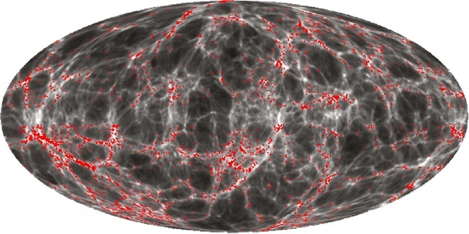

Figure 1. Mollwiede projection in galactic coordinates of all galaxies from the 2MRS catalog.

The four-dimensional map of the Universe created in this way showed a strange, hitherto unknown picture of the “Cosmic Web” in which galaxies and groups of galaxies connected in filaments and chains, somewhat like spider webs, forming large three-dimensional cellular structures. Between these filaments and chains, enormous voids, tens to hundreds of millions of light years in size and almost devoid of space bodies, are visible. The galaxies that are part of the observed fibrous spatial structures seem to be connected with each other by invisible forces. Thus, the emerging large-scale images for the first time shows matter in the form of stars and galaxies embedded in a uniform and highly porous cosmic entity united by invisible forces (Fig. 1).
The obvious question that comes to mind is by what forces are these galaxy groups sustained to build such an incredible and highly complex lattice. Astrophysicists unanimously answered this question that it is the forces of gravity, well known from the works of Galileo and Newton, which are responsible for the construction of this template. However, before that happened, it turned out that the long-known principles of the movement of cosmic bodies only work relatively well in the area limited to the Solar System. The stars orbiting the centre of the galaxy do not seem to move as expected from Newton's laws. This was discovered in 1978 by the American astronomer Vera Rubin (1978), who, by studying the rotational speeds of stars in brightly shining spiral galaxies, proved that stars more distant from the centre of galaxies do not move slower than those closer to the centre, as would be indicated by Newton's laws. Their orbital motion is more rigid-flexible [??] than it is similar to the spokes of a bicycle wheel. Most of the stars moving in the galaxy are more or less similar in speed, regardless of their distance from the centre of the galaxy. To explain this paradox, many times more mass than what we observe in galaxies was needed. Thus, the so-called galaxy rotation problem has arisen. To avert this crisis, an ad hoc new form of cosmic matter, endowed with mass, invisible and not interacting with matter known to us, was invented. It has been called "dark matter". This mysterious dark matter, endowed with great mass, could strengthen the weak force of gravity of the insufficient amount of baryon matter known to us and, being used as a binder, cement the stars of the galaxy so that they could all move with similar angular velocity. Mathematical simulations confirmed this hypothesis, which satisfied most scientists, but left a question mark about the nature of this mysterious dark matter, which after all cannot be investigated. This situation may remind the mathematically correct geocentric model of Ptolemy, which, being mathematically correct, survived many hundreds of years before being crushed by the introduction of the heliocentric model of Copernicus.
The strong gravity caused by dark matter was also useful in explaining the mechanism of the formation of a kind of invisible filament on which, as shown in (Fig. 2), galaxies are strung like connected beads building this three-dimensional spatial network of the large-scale pseudo-cellular structure of the Universe. Without the help of the dark matter's much more powerful gravity, the gravitational force of galaxies would be too weak to build such a macro-spatial network. The huge, ever-expanding voids in the pattern shown in the image between the fibers of the galaxies were considered the result of another, also ad hoc, invented component that builds up to 70% of the Universe, Dark Energy. Now everything was correct in the mathematicians' calculations. The only problem, however, is that no-one is able to explain what they are and what is the nature of these ad hoc invented components that build up 95% of the Universe. But is it necessary to resort to such mysterious dark powers to explain the nature of the universe?
Gravity is considered by physicists to be the weakest force known to us in nature. A much more powerful force is the well-known force of electromagnetism. Although both the force of gravity and the force of electrostatic interaction propagate according to the same law, i.e. inversely proportional to the square of the distance, the gravitational force for a proton and an electron is 39 orders of magnitude smaller than the electromagnetic forces. This power difference is so overwhelming that it is hard to even imagine. The force of gravity is up to a billion quadrillion and once again quadrillion times weaker than the electromagnetic forces. Thus, the invention of the mysterious dark matter, greatly enhancing the forces of attraction between galaxies, has become, from a mathematical point of view, a very useful but unreliable addition for debating the nature of the formation of the great structure of the universe. Relying on the interactions caused by the forces of electromagnetism, it may well replace the forces of dark matter.

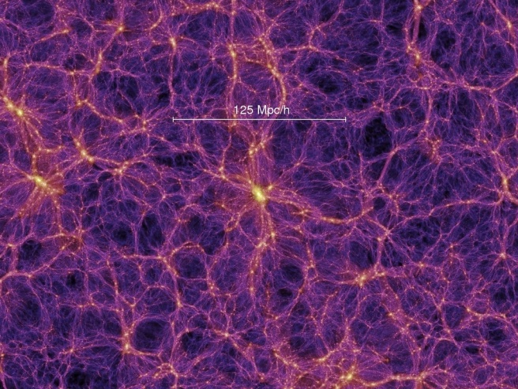

Figure 2. A computer simulation of the great structure of the universe shows the fibrous-feathered connections of galaxies enclosing enormous voids. (universetoday.com)

Knowledge of the electromagnetic properties of the universe is still in its infancy and requires intensive study. However, it already seems obvious that electromagnetic forces, being 39 orders of power stronger than gravity, could be the driving force shaping the great structure of the observable universe. Despite such a great difference in power between the electromagnetic forces and gravity, many scholars reject this obvious solution, believing that there is no point in asking ourselves what is the relative power between these forces. It is also argued that electromagnetism could have a great influence in shaping the distribution of matter in the cosmos only if there would be an unequal charge between fragments of space. Such inequalities have not been observed so far. However, research on this topic is still in its early stages.
Such a charge will be created on the surface of a water droplet suspended in air, or at the surface of the air bubble immersed in water. Such an electric charge usually appeared at the interface (phase boundary) of media with different electrical properties. Accumulations of the electric charge will cause the flow of electric current, creating a magnetic field, and thus activating the forces of electromagnetic interactions between apparently electrically neutral bodies immersed in these media. But where can one look for different electric charges in this empty cosmic space?
Huge intergalactic spaces, by analogy with aqueous solutions, are not empty as it might seem at first glance. They are filled with high-energy quantum fields of various viscosities, electromagnetic fields, cosmic rays, and rarefied and ionized gases, as well as clouds of electrically charged cosmic dust. This high-energy environment of the cosmic environment is subject to constant fluctuations (Linde, 1982) as a result of which not only baryon matter was formed, but the large-scale spongy structure of the Universe can be shaped, as was hypothesized earlier (Żbik, 2018).
It is known that electrostatic force arises between bodies with different electric charges and does not occur in the case of electrically neutral bodies. In the case of electrically neutral bodies, an electric charge spontaneously arises at the phase boundaries separating these bodies, which usually have different electrical properties (eg. they differ in the values ​​of the dielectric constant, for example).
The obvious evidence for the penetration of the electromagnetic field through the entire visible area of ​​the Universe is that we can see distant galaxies occurring in this area through optical telescopes and radio telescopes. Light rays (photons) or radio waves reach us overcoming these extremely large distances. These photons are vibrations of the already existing electromagnetic field. In the case when this field would not be present there, we would not be able to see any light coming from distant galaxies because there would be no medium to be excited. The consequence of this is the conclusion that all visible space in the universe may be of the electric nature. In case when our Universe may lie on the event horizon of a singularity, as was hypothesized in Żbik (2020), so this black hole may be electrically charged which is consistent with the Hawking black holes theory.
Therefore, if the environment of the interstellar space within galaxies is to a different degree penetrated by the electromagnetic in comparison to the intergalactic space, it shall result in differences of electrical conductivity (dielectric constant) between these media. The consequence of this difference may result in the induction of electric charge between the outer and inner galaxy space environment. Such a phenomenon may not lead to electrization of the galaxy medium itself. But does the galactic medium remain electrically neutral?
This question has already been partially answered by the results of plasma density measurements outside the solar system, recently measured by the Voyager 1 space probe. It turned out that the density of free electrons there is higher than inside the heliosphere bubble. The interstellar space of the Galaxy is therefore not electrically neutral but is a highly electrically active medium filled with electrically active plasma. Plasma, an electrically active medium, is the fundamental state of aggregation occurring in outer space. But could this be the only source of electric charge in galaxies?
To answer this question, start with a more familiar example from the school's physics practice. If you rub amber or a plastic stick with a cloth, the resulting electric charge will attract small pieces of paper to it, or it will spread the metal foil leaves inside the electroscope (Fig. 3 left).
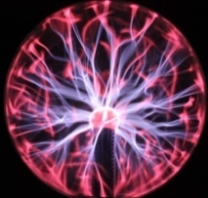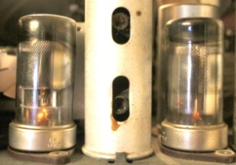
B
C

Figure 3. A- A plastic or glass tube rubbed with fur after touching the electroscope terminal shows a strong electrostatic charge of the spreading metal foil leaves. Plasma strings generated by high voltage generator, within reduced pressure atmosphere. In a vacuum inside the radio tube, the current flows freely from the heated cathode to the anode without causing any light effects in this medium. (Photo by M. Żbik)

Such rubbing plastic pipe over the furry surface generates an electric charge, which in turn causes the expansion force of the metal foil wings inside the electroscope. Discharge of this voltage through the flow of charges (current) takes a relatively long time in the atmosphere and depends on its humidity. Inside the glass ball filled with air of very low pressure (Fig. 3 middle) placed on the high voltage generator, there are streaks of discharge plasma on which electric current flows like mini-lightning to the outer wall. In the high vacuum as shown inside a radio tube (Fig. 3 right), the current flows freely from the heated cathode to the anode without causing any visual effects.

- DISCUSSION
When lying in a meadow or on a beach, we look at the clouds forming in the sky, we can see, as it is shown in (Fig. 4 left), that water vapors condensing into tiny water droplets suspended in the air does not leave them evenly distributed in the atmosphere. They clump together to form fibrous looking fillies, and great areas of clean air lie between these feathery filaments. What attracts these miniature droplets together to form these highly porous fluffs? Well, as a result of the differences in the dielectric constant of air and water, an electric charge is generated at their phase boundaries. Charges of the neighboring droplets undergo polarization, causing this mutual attraction and the formation of long flocks, which in turn combine with others to form the cloud observed in the sky. The cloud however, thickens, transforming quickly into a menacing-looking thundercloud. Then, tiny droplets of water and ice, hitherto suspended quietly, held only by the forces of electrostatic attraction, are violently disturbed.
Scientists are still studying the details of the charging process, but there is general agreement on some basic concepts for storm electrification.
Electrification can be a triboelectric effect as a result of ion transfer between colliding particles.
Colliding grains and particles can become electrified as a result of charge transfer between them (as free ions) in an electric field that occurs in a storm cloud. As a result of the strong turbulence inside the storm cloud, more and more fragments of the cloud are subjected to electrification.
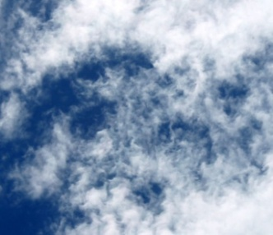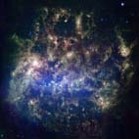

Figure 4. The fluff-feathered structure shows the similarities, in the clouds in the sky, and in the Large Magellan Cloud.

As a result of the insulating properties of air, the flow of charges between the differently charged portions of the cloud is limited to the flow of a very small amount of electric current. However, when the charge builds up to its limit value over time, a breakdown occurs and a corridor of ionized gases is formed in the air and along which, as in Figure (Fig. 3 middle), an electric current of great intensity flows, the formation of lightning. Then, in the resulting plasma corridor, the gas temperature rises rapidly to about thirty thousand degrees, there is a blinding flash of strobe lightning light, and the air is pierced by the deafening roar of thunder. In April 2020, a single flash, as shown in Fig. 5 lit up the sky for 768 kilometres across three southern states, they reported in the Bulletin of the American Meteorological Society this week.
The flow of the electric current thus created is also accompanied by a sudden magnetic pulse, which may be heard on the radio as a series of dry clicks. Thus, it can be said that the cloud in the atmosphere is a highly electrically complex environment, and its structure is largely determined by electrostatic forces. Gravity for these tiny cloud-building particles of water and ice can be neglected, at least until rain or hail drops increase, which will fall out of the cloud's environment onto the planet's surface. Not only particles of water and ice can become electrified, so do dust particles. How similarly is the flocculent structure of the cloud in the atmosphere similar to the dust-gas cloud seen in the Large Magellanic Cloud viewed through a telescope (Fig. 4 right)?

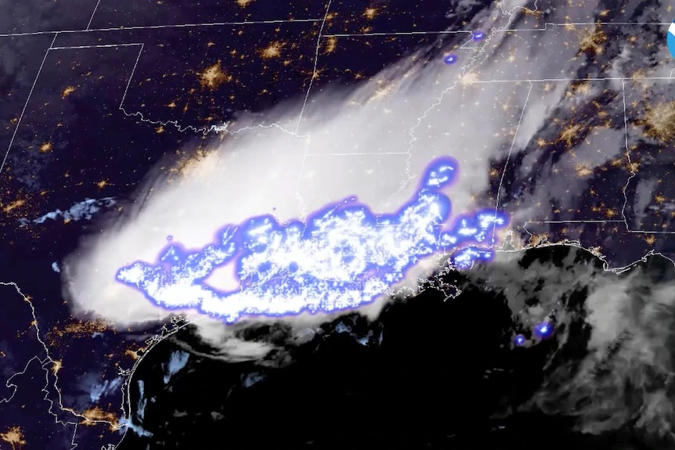

Figure 5. The world's longest lightning strike lit up the skies 768 km across Mississippi, Louisiana and Texas (NOAA via AP)

A strong magnetic field has also been recorded in the turbulent environment of the Large Magellanic Cloud by astronomers with the Parkes Radio Telescope in Australia (Mao et al., 2018). Interestingly, it has been noticed that magnetic connections with invisible filament connect both Magellan clouds and also indicate extension of the similar connections with our Galaxy.
Dusts in the turbulent environment of dust-gas clouds can also be highly charged. Volcanic lightning is quite common during volcanic eruptions, occurring in about one-third of all eruptions. In some cases, a very large number of lightning strikes can be seen. In a study conducted by the University of Florida in the program to study electrical discharges in dust rising from erupting volcanic chimneys, one plume produced about 300 lightning as shown in the spectacular illustration (Fig. 6). Here, too, the sudden flow of electric current caused magnetic disturbances and the generation of an electromagnetic wave.
Volcanic lightning is a weather phenomenon in which lightning is formed in the plume of an erupting volcano. It is also known as a dirty thunderstorm or volcanic storm. The term "dirty storm" refers to the fact that lightning is produced by ash particles and other ejections that clash together in the air during an eruption, generating an accumulation of static electricity in various parts of the plume's dust and gas cloud.

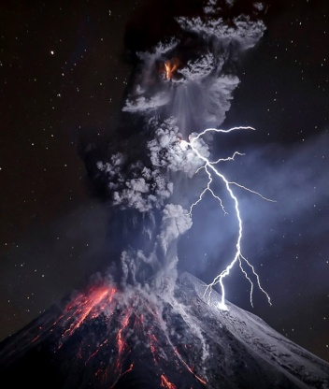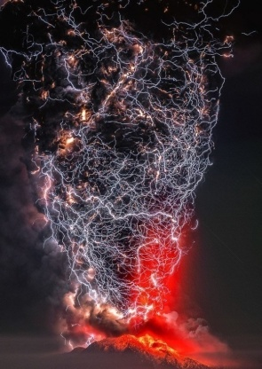

Figure 6. Electric discharges inside the dust clouds of an erupting volcano. (Wikipedia)

The natural radioactivity in the elements contained in volcanic ash can also contribute to the self-recharging of volcanic ash clouds.
Laboratory measurements of particle size distribution, triboelectrification and radioactivity in ash samples from the volcanic eruptions of Grímsvötn and Eyjafjallajökull in 2011 and 2010, respectively, proved that volcanic ash/dust particles are charged electrically, producing one of the most spectacular lightning shows in nature. The article by Genareau, (2015) presents the factors influencing the electric charging of ash from two different Icelandic volcanic eruptions (Eyjafjallajökull in 2010 and Grímsvötn in 2011). The Eyjafjallajökull eruption resulted in a well-documented flight ban over most of Europe for several days.
One of the earliest extant descriptions of volcanic lightning comes from the Roman Empire, where historian Pliny the Younger wrote about the eruption of Mount Vesuvius in AD 79. He described it as "the most intense darkness made more terrifying by the whimsical glow of torches at intervals, obscured by the transient glare of lightning." The formation of lightning can also occur not only in the volcanic ash cloud during eruptions, but also in the dust of sand storm clouds, forest fires, tornadoes, and even during cold winter, when lightning is generated in wind-blown clouds composed of ice grains. Thus, the electrification of clouds of various substances consisting of small particles strongly abrading with each other due to turbulence causes the formation, accumulation and increase of the electric potential, which in turn leads to sudden discharges in the atmosphere during which an electric current of high intensity flows, and thus generates a pulse magnetic and an electromagnetic wave propagates.

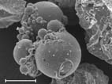

Figure 7. Spherulites formed as a result of the passage of lightning through a volcanic ashes cloud. Fragment of the stony meteorite filled with chondrules are suspected of being formed as a result of lightning bolts inside dust-gas clouds in the proto-planetary ring of the emerging planetary system.

Interestingly, when lightning passes through a cloud of volcanic ash, the high temperatures result in the dust melting, partially evaporating, and forming glassy spherulites (Fig. 7 left), also called spherules, a sort of atmospheric fulgurites. Glass spheres have been documented in many geological deposits, and their genesis is linked to high-temperature processes, which include lightning strikes in clouds, volcanic eruptions, and meteor strikes. The research presented by Genareau et al. (2015) reviewed the known processes of glass ball formation and proposed for the first time a mechanism induced by the heat generated by lightning generated inside volcanic ash clouds floating in eruptive columns and plumes (volcanic clouds spreading to the sides) during explosive volcanic eruptions. Ash samples were collected from two eruptions in which volcanic lightning was documented from the 2009 Mount Redoubt eruption in Alaska (USA) and the 2010 Eyjafjallajökull eruption in Iceland. These samples show single glass spheres with an average diameter of 50 μm which represent <5% of the tested part of the catch sample taken. The textures of the spherules of volcanic fulgurites include smooth, hollow or cracked grains as well as their aggregates, which suggest ash particles melting due to the proximity of the electric discharge channel and then solidification of the particles into spherical morphologies. It has been established that volcanic ash particles can be transformed into glass balls by the heat generated by electrical discharges inside a gas-dust cloud during volcanic eruptions, and their presence may indicate the occurrence of electrical discharges in volcanic ash-gas clouds.

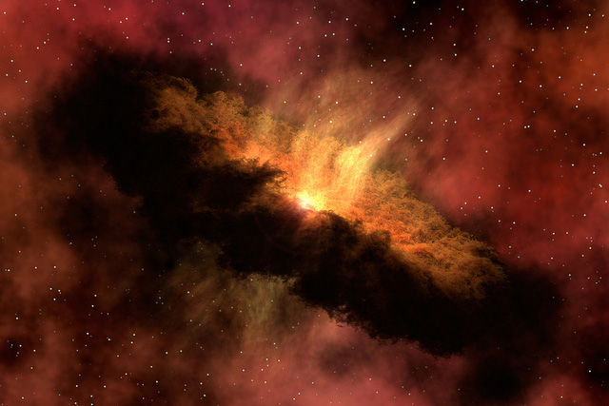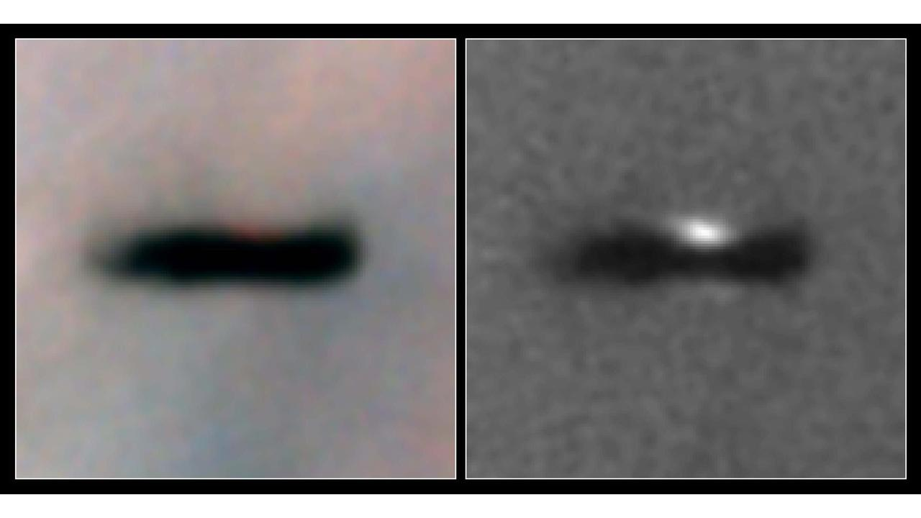
Figure 8. Image of the ring of the dust-gas cloud of the PP cloud formed around a newly emerging star. ( NASA / JPL-Caltech ), and the PP disk observed through the telescope inside the Orion Nebula (NASA).

There is no atmosphere in cosmic space; there is a deep vacuum, so lightning cannot arise in such an environment. Still under low pressure in high layers of the atmosphere, we are dealing with the phenomenon of aurora, where streaks of glowing plasma can be seen as in a lamp with low air pressure in a high voltage generator (Fig. 3 middle). However, in some unique places in space, usually highly rarefied dust and gas clouds concentrate to form an atmosphere-like environment. These places include regions of the protoplanetary (PP) discs. Relatively thin rings form a dense cloud of gases and primary interstellar dust, remnants of the former interstellar dust and gas nebula, around newly emerging stars. The vast and relatively thin protoplanetary ring (Fig. 8 up), pressed tightly into the strong magnetic field of a forming protostar, and initially contains hot gases and vapors. In this very thin ring, relatively high temperatures and pressure prevail, which favors the occurrence of strong turbulence there. As the temperature drops in these gases, mineral grains begin to condense, which is described in detail in the book Żbik (2019).
This environment is highly turbulent, and condensing mineral grains mixed with hot gas and plasma are in constant electric motion charging individual fragments of this protoplanetary disk cloud. In this environment extremely rich in short half-life radionuclide (not existing at present) from recent supernova explosions in the area, high levels of natural radioactivity can also contribute to the self-charging of PP cloud fragments and frequent electrical discharges in the form of lightning. Mineral dust under the influence of such discharges melts and, similar to fulgurites volcanic spherulites, can generate the seeds of the most primeval bodies in the emerging planetary systems (Fig. 8 down) of highly refractory CAI grains and chondrules.
In the case of the solar system, the most primeval material of the solar system is the CAI (Calcium-Aluminium-rich Inclusions) grains found in stone meteorites, dated as 4.5673 billion years old. This age counts as the birth of our planetary system, age zero of the planetary system. About one to two million years after CAI formation, since time 0 of the Solar System, with a further decrease in the temperature of the protoplanetary disk, the first silicates condensing from the cooling gas and mineral grains as pyroxenes and olivine were formed (1290–1360 K). From these tiny silicate crystals, with a continuous decrease in the temperature of the PP disk and as a result of processes still unknown to us, causing rapid heating and melting of the formed mineral grains, mysterious spherical objects called chondrules were born (Fig. 7 right). It is believed that repeated episodes of shock heating with the subsequent equally rapid cooling of the dust-gas reservoir in the PP disk could have occurred as a result of the course of plasma waves from protosolar outbursts and electrical discharges. These cosmic lightning bolts, stretching their bright tentacles of lightning in the ecliptic plane of the dense PP disk, pierced the cooling dust-gas cloud, which could lead to processes similar to those observed in volcanic dust clouds. This still hotly debated process led to the formation of chondrules, which emerged as distinct, millimeter-sized cosmic bodies 1-2 million years after the CAI was born, solar system 0. The oldest chondrules known to us, ranging in age from 1 to 3 million years from the beginning of the scale, were measured in the Bishunpur (LL3) meteorite, the most primitive of the class of common chondrite. The CAI grains and little later formed chondrules are therefore the oldest objects of the Solar System, most likely born of strong electric discharges in a slowly cooling protoplanetary disk, similar to the fulgurites spheres formed inside dust-gas clouds of erupting volcanoes. The massive occurrence of chondrules in the initial period of planetogenesis may therefore indicate the presence in PP of strong electric fields and continuous lightning, the longest known to our planetary system, a monstrous storm lasting millions of years.

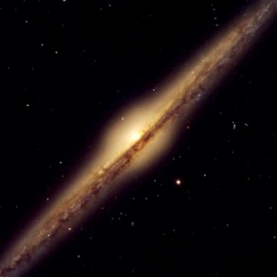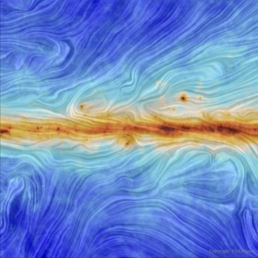

Figure 9. A- Like rain clouds looming on a stormy day, dark lanes of dust and gas clouds intersect in half the giant spiral galaxy "Needle" (NASA). Mapping the distribution of magnetic field forces observed in the plane of our Galaxy. (Wikipedia)

Another environment in which dust and gas clouds mix turbulently can be found in the plane of the galaxy's discs, which when viewed in profile show a dark line, the area of ​​intense concentration of these clouds, as in (Fig. 9 left). The nature of the dust and gas clouds in the plane of galaxies is somewhat different than in the plane of protoplanetary disks. They are much more thinned and highly ionized. In this high vacuum atmosphere, lightning bolts do not have the conditions to form, but differences in electric potentials may arise as a result of their constant turbulent mixing. This does not mean, however, that there are no electric current flows within galaxy disk. Likewise inside a radio tube, electric current flows in a vacuum as free ions. Mainly a stream of electrons from the heated cathode flows to the anode. Inside the dust and gas clouds of galaxies, the heating instrument may probably be stars that sow ionizing gases abundantly with the solar wind, through which such a plasma environment electric current can flow without major obstacles. Lightning and thunder in such an environment do not arise, and the flow of electric current does not have the characteristics of sudden discharges as it does within the atmosphere, but flows continuously, similar to the current flow inside a radio tube, a diode (Fig. 3 right).

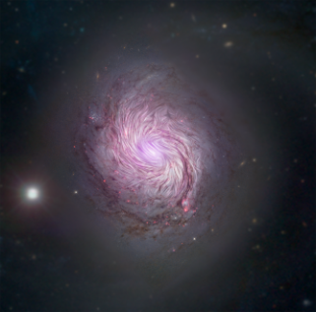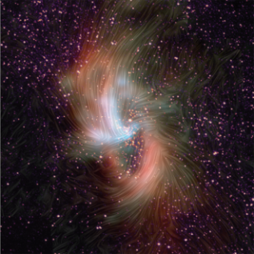

Figure 10. A- Mapping of force lines of a magnetic field in the adjacent spiral galaxy M77, and distribution of magnetic field lines around the dusty ring of a massive black hole in the centre of the Galaxy. (NASA, JPL-Caltech and Roma Free University)

The question then arises whether it is possible to tell if electric current is flowing inside galaxies? Yes, it is possible. The flow of electric current creates a magnetic field. Thus, observing the magnetic field in galaxies gives us irrefutable evidence that electric currents flow in this environment, as shown in (Fig. 9 right).
Without going into technical details and methodology, a tool for studying the magnetic field structures in galaxies turned out to be the polarization of radio radiation emitted by superfast electrons moving around the force lines of an ordered magnetic field. Pictures of such lines of magnetic field lines are shown in (Fig’s. 10 and 11) It should be mentioned here, according to Urbanik (2007), about the outstanding astronomers from Krakow under the supervision of Dr. Marian Soida from the Astronomical Observatory of the Jagiellonian University, who already at the end of the 1990s, in a combined team of radio astronomers from Krakow and Bonn, using a 100-meter radio telescope MPIfR and a system of 29 connected antennas in the USA (the interferometer called Very Large Array - VLA), discovered spiral, strongly inclined magnetic fields in galaxies, the so-called Fluff-feathered galaxies, which have a structure different from typical spiral galaxies, and in which, without the apparently shaped arms of the dust and gas clouds, the occurrence of a magnetic field was not expected. The process responsible for the formation of magnetic fields in galaxies is not yet well understood. Proposed as one of the possible (apart from the possible effect of electrifying dusts), the so-called galactic dynamo is one of the options under consideration, but it does not explain many observational data in light of which the currently measured galaxy magnetic field strength is of the order 5–15 µGs.
Constable (2015) portrayed the environment of the Solar System as a highly electromagnetic system. Fontani (2016) also showed how much underestimated the role of magnetism in the universe was so far. According to him, electromagnetic forces play an important role in the fragmentation processes of molecular clouds from which new stars are born. The fragmentation of these proto-stellar clouds is also fibrous in nature, visibly shaped in a magnetic field.
In the last two decades, extensive magnetic fields generated inside galaxies, extending into deep interstellar and intergalactic spaces, have also been discovered. The cosmos is full of ionized matter. Electrically charged plasma is the most common physical state of baryon matter in the universe. Electrically charged stellar wind plasma fills the intra-galactic environment, and powerful jets of charged particles are projected at relativistic velocities perpendicular to the galaxy's plane from their central region. These plasma streams seem to be part of the exchange of matter and electric charge between galaxies close to each other. All of this shows the cosmos as a system of electrically interconnected elements. This intricate electrical system that is the observable universe appears to be a tiny fragment of an extra-great magnetic monopoly that extends well beyond the horizon of the visible universe.

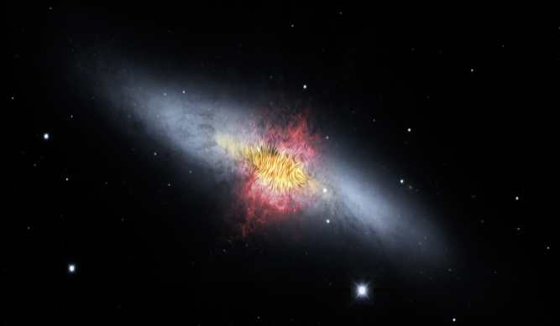

Figure 11. The Cigar Galaxy shows strong concentrations of magnetic activity around its centre. (Wikipedia)

Knowledge about the electromagnetic properties of the universe, despite the large amount of incoming data, is at present still in its infancy and requires intensive study. However, it already seems obvious that electromagnetic forces, being much stronger than gravity, can be the driving force shaping the great structure of the observable universe. Despite such a great difference in power between the electromagnetic forces and gravity, many scholars still hold the position that there is no point in asking ourselves what the relative power is between these forces of gravity and electromagnetism. It is also argued that electromagnetism could have a great influence in shaping the distribution of matter in the cosmos only if there would be an inequality of charges between cosmic bodies. So far, no one has directly measured electric charges in space. The discovery of strong magnetic fields in the nebulae inside the Galaxy, in the region of a giant black hole in the galactic centre, in the emerging proto-solar and proto-planetary nebulae, as well as magnetic fields covering entire stretches of galaxies extending far beyond their boundaries, belies the above thesis and indirectly proves it indirectly about the flow of electric current inside the galactic medium, and therefore about the presence of electric charges within all space filled with galaxies.
The distinct fibrous structures of the great map of the Universe may indirectly indicate that the interactions between galaxies are electromagnetic in nature. Similar structures can be observed in the micro world of discoidal rigid-elastic mineral particles in colloidal water suspensions. Due to the significant difference in the dielectric constant, the colloidal particles, neglecting the gravitational gravity and displaying a strong electric charge, polarize each other at a distance and combine into complex fibrous spatial networks (Fig. 12) resembling the illusions observed in three-dimensional representations of the great structure of the Universe. These structural analogies between environments as different as cosmic and aqueous colloidal suspensions as shown in Zbik (2018) are not accidental, because Albert Einstein, thanks to the study of colloidal suspensions, was able to describe the mechanics of atomic water molecules in electrolyte solutions, thus giving an outstanding scientific achievement in the field of molecular physics and Brownian motion, another scientist Casimir (1948) discovered the vacuum energy while studying the Van der Vales forces while also working on the stability of colloidal suspensions.

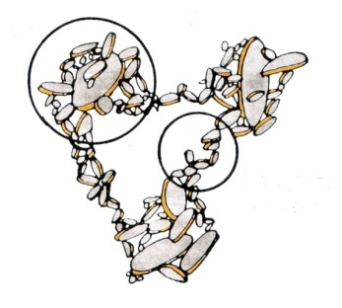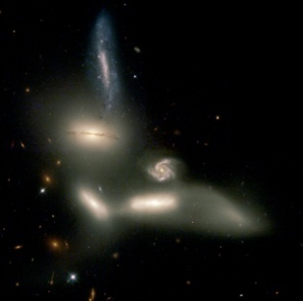

Figure 12. Model of the formation of a three-dimensional fibrous structure that electrically charged clay minerals build in colloidal solutions of water electrolytes.

- CONCLUSIONS
From the above-outlined concept, it can be assumed that the observed spatial superstructure of the Universe presents a highly porous, fibrous medium strung on invisible threads of galaxies' electromagnetic fields is immersed in the space-time environment of quantum fields of various viscosities. The whole “Cosmic Web” environment along which the electric current flows through the "fibers" builds a gigantic electrically active mechanism of unknown nature and destiny, within which we constitute an extremely tiny fragment without even realizing it.
REFERENCES
Beck R., Magnetic Fields in Spiral Galaxies, Astronomy and Astrophysics Review, Volume 24, id.4, 2016.
Beck R., Hoernes P. Magnetic Spiral Arms in the Galaxy NGC 6946, Nature, 379, 47-49, 1996.
Beck R., Wielebinski R. Magnetic Fields in Galaxies, in: Planets, Stars and Stellar Systems Vol. 5, Springer, Dordrecht, 641-724, 2013.
Beck R. Magnetic fields in the nearby spiral galaxy IC 342, Astronomy & Astrophysics, 578, A93, 2015.
Bührke T. Forces that Rule in Galaxies, Max Planck Research 1, 34-41, 2015.
Casimir H.B.G. On the attraction between two perfectly conducting plates. Koninklijke Niderlands Akademie van Westenchapp. Proc. Series B, Physical Science B51, 793-795, 1948.
Constable C. Earth‟s Electromagnetic Environment. Surv Geophys. DOI 10.1007/s10712-015-9351-1, 2015.
Davis T.M., Lineweaver Ch.H. Expanding Confusion: Common Misunderstanding of Cosmological Horizons and the Superluminal Expansion of the Universe. Astr. Soc. Aust. 21, 97-104, 2004.
Einstein, A. Über die von der molekularkinetischen Theorie der Wärme geforderte Bewegung von in ruhenden Flüssigkeiten suspendierten Teilchen. Annalen der Physik . 322 (8): 549–560, 1905.
Fontani F., Commerçon B., Giannetti A., Beltrán M.T., Sánchez-Monge A., Testi L., Brand J., Caselli P., Cesaroni R., Dodson R., Longmore S., Rioja M., Tan J.C., Walmsley C.M. Magnetically regulated fragmentation of a massive, dense, and turbulent clump. Astronomy & Astrophysics 593, L14, 2016.
Genareau, K., Wardman, J.B., Wilson, T.M., McNutt, S.R., Izbekov, P. Lightning-induced volcanic spherules. Geology. 43 (4): 319–322, 2015.
Górski K. M., Hivon E., Banday A. J., Wandelt B. D., Hansen F. K., Reinecke M., Bartelmann M., ApJ, 622, 759, 2005.
Gott III J.R., Juric M., Schlegel D., Hoyle F., Vogeley M., Tegmark M.T., Bahcall N., Brinkmann J. A map of Universe. The Astrophysical Journal, 624, 463–484, 2005.
Klein U. Fletcher A. Galactic and Intergalactic Magnetic Fields, Springer, Heidelberg, 2015.
Lietzen H., Tempel E., Liivamägi L. J., Montero-Dorta A., Einasto M., Streblyanska A., Maraston C., Rubiño-Martín J. A., Saar E. Discovery of a massive supercluster system at z _ 0:47, Astronomy & Astrophysics manuscript no. superar cESO, 2-4, 2016
Linde A. A new inflationary universe scenario: A possible solution of the horizon, flatness, homogeneity, isotropy and primordial monopole problems. Physics Letters B. 108, 6, 389–393, 1982.
Mao, S.A., McClure-Griffiths, N.M., Gaensler, B.M., Haverkorn, M., Beck, R., McConnell, D., Wolleben, M., Stanimirovic, S., Dickey, J.M., Staveley-Smith, L. Magnetic Field Structure of the Large Magellanic Cloud from Faraday Rotation Measures of Diffuse Polarized Emission. DRAFT VERSION NOVEMBER 1, 2018 Preprint typeset using LATEX style emulateapj v. 08/13/06 2018.
Rubin V.C., Ford W.K.Jr., Thonnard N. Extended rotation curves of high-luminosity spiral galaxies. IV - Systematic dynamical properties, SA through SC. Astrophys.J.Lett. 225, L107-L111, 1978.
Rüdiger G., Hollerbach R. The Magnetic Universe, Wiley-VCH, Weinheim, 2004.
Wiltshire D. Timescape Cosmology: Modifying the Geometry of the Universe. Physical Review D 88, 083529, 2013.
Urbanik M. Namagnesowane Galaktyki. FOTON 99, Zima 2007, 9-16, 2007.
Zbik M.S. Flocculated Universe is the Universe an Electromagnetic Entity? SSRG Int. J. Geoinf. & Geol. Sci. (SSRG-IJGGS) Vol 51, 3, 24-29, 2018.
Zbik M.S. The Universe as two-dimensional membrane on the event horizon of singularity. SSRG Int. J. Geoinf. & Geol. Sci. (SSRG-IJGGS) Vol 7 Issue 2, ISSN: 2393 - 9206 2020. www.internationaljournalssrg.org Page 21

